Version 1.0

Revision History

|  |  |  |  |
| --- | --- | --- | --- |
| **Date** | **Version** | **Description** | **Author** |
| 15/12/2019 | 1.0 | details | Hoang Trung Hieu |
|  |  |  |  |
|  |  |  |  |
|  |  |  |  |

Table of Contents

1. Introduction 4

1.1 Purpose 4

1.2 Scope 4

1.3 Definitions, Acronyms, and Abbreviations 4

1.4 References 4

1.5 Overview 4

2. Business Use-Case Name 4

2.1 Brief Description 4

3. Goals 4

4. Performance Goals 4

4.1 <name of performance goal> 5

5. Workflow 5

5.1 Basic Workflow 5

5.1.1 <name of workflow step> 5

5.2 Alternative Workflows: Still achieve success but in different way 5

5.2.1 <name of workflow step> 5

6. Risk 5

7. Possibilities 5

8. Process Owner 5

9. Special Requirements 5

9.1 <Name of Special Requirement 1> 5

9.2 <Name of Special Requirement 2> 5

10. Extension Points 6

10.1 <Name of Extension Point> 6

Business Use-Case Specification: Order Product

# Introduction

## Purpose

The purposes of this business use-case is to show how the computer shop deals with the situation when customers want to order computer at this shop

## Scope

The scope of this business use-case is associated with the computer shop to be deployed

## Definitions, Acronyms, and Abbreviations

Employee – a person who work for the computer shop.

Guest – a user who is not logged in the system.

## References

## Overview

The rest of the Business Use-case Specification contains goal, risk, process owner and special requirement.

# Business Use-Case Name

## Brief Description

The use-case here is that “Order Products”, which means in a specific situation, the computer is available at shop and customer can order it immediately.

# Goals

The goal of the business use-case is to help customer order product which is still available in shop successfully.

# Performance Goals

## <Customer can order product >

This perfomance goal is about the final state of the use case when the customer can order product which is still available in store.

# Workflow

The user adds computer to order items list (cart). And then, the user goes to order computer page and the system prompts user for information(name, address, email, address, etc). The user will enter their information and push enter to the system validates information. The system prompts the user to confirm order then saves the ordered information to database. The system notifies an employee to deliver the ordered items to user. the emplyee delivers the ordered items to the user at specified address and the user pays money

## Basic Workflow

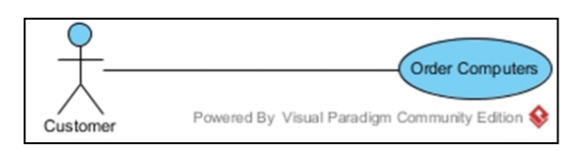

# Risk

No special.

# Possibilities

No special.

# Process Owner

The process owner if this usecase is the administrator or can be called manager of the computer shop who deal with the situation.

# Special Requirements

No special.

# Extension Points

## <No extension Point>